

**Real Madrid App Sentiment Analysis**

Real Madrid is one of the largest Football Cub in Europe , commonly referred to as Real Madrid or simply Real , is a Spanish professional football club based in Madrid. Founded in 1902 as Madrid Football Club, the club has traditionally worn a white home kit since its inception.

Here the Application used for sentiment Analysis is Real Madrid App. The analysis is based on the Real Madrid app reviews collected from Google play store.

**Objective**

Based on recent 500 reviews of Real Madrid app in the Google play store, Understanding the Sentiment of the users of the app towards the working and functions of the app.

**Data Information**

The app consist of more than 10M of downloads and 4.6 rating out of 5. There more than 175K reviews on this app. From this reviews here I used recent 500 reviews for the analysis. From this analysis I focus on understanding how is the attitude and sentiment of the users and Real Madrid fans towards the app right now , that is why selected recent 500 reviews. This review are from different peoples from different countries.

**Data Pre-processing**

The Data collected from the App review are make it into data frame

with the below column names.

source, review_id, user_name, review_title, review_description, rating, thumbs_up, review_date,developer_response, developer_response_date, laguage_code'.

From the Data I take out the review column because our analysis in based on this reiew.

* **Data Cleaning**

There are lot of cleaning task I was performed on the review

Because, They are :

## Remove accented characters

## Remove special characters

## Text lemmatization

## Remove stop words

## Emotion and Sentiment Analysis

## From the Real Madrid App, based on recent 500 reviews Majority of the reviews shows a positive Attitude or sentiment towards the functions of the app.

* **Positive 302**
* **Neutral 184**
* **Negative 14**

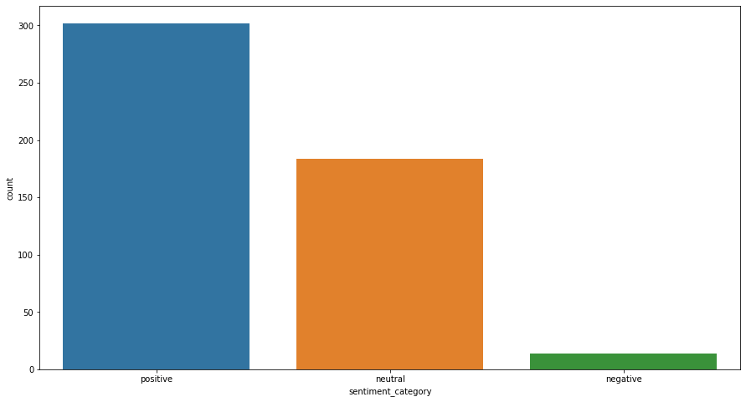

The above count plot Shows the sentiment of recent 500 reviews of the football fans .

From that Positive sentiment of 64 %, Negative sentiment of 2.8 % only. Rest 36 %

are Neutral.

**Conclusion**

In the initial stage of the Real Madrid app has lot of bad reviews on the working and

functions of this app. But Based on the latest analysis we can conclude that the app have lot off improvement based on the requirement of target people, that is soccer fans.

*Submitted by* : **AKSHAY MP**